PERSONAL EXPENSE TRACKER

PNT2022TMID2101

**Sprint-3**

SCREENSHOT

Home-Page:

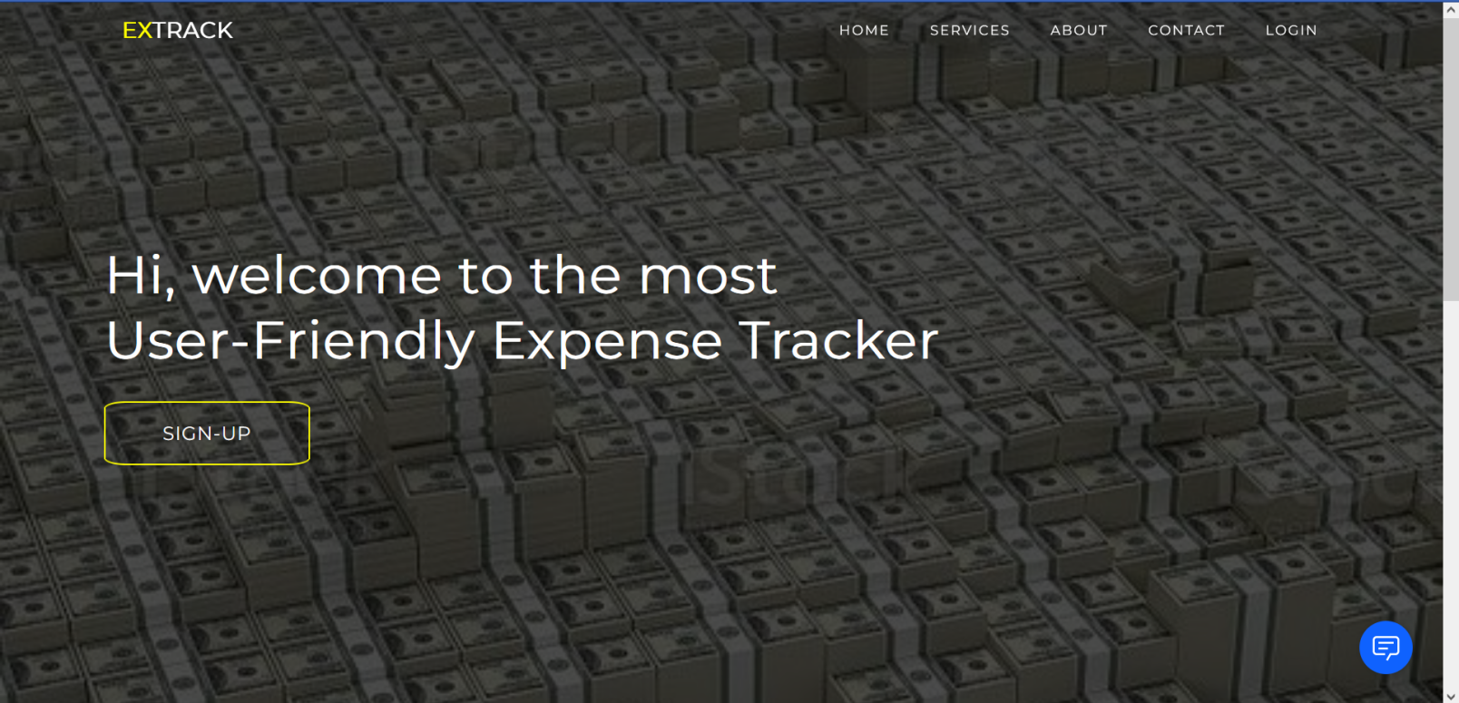

Chat-Bot:

